RESOLUTION NO.__________

RE: CERTIFICATE OF APPROPRIATENESS UNDER THE

PROVISIONS OF THE ACT OF THE PENNSYLVANIA

LEGISLATURE 1961, JUNE 13, P.L. 282 (53

SECTION 8004) AND BETHLEHEM ORDINANCE NO.

3952 AS AMENDED.

WHEREAS, it is proposed to add braces to the rear porch at 321 E 4thStreet.

NOW, THEREFORE, BE IT RESOLVED by the Council of the City of Bethlehem that a Certificate of Appropriateness is hereby granted for the work.

Sponsored by: (s)

(s)

ADOPTED BY COUNCIL THIS DAY OF

(s)

President of Council

ATTEST:

(s)

City Clerk

HISTORIC CONSERVATION COMMISSION

CASE # 592– It is proposed to add braces to the rear porch at 321 E 4thStreet

OWNER/APPLICANT: Touchstone/Graham Stanford

The Commission upon motion by Mr. Traupman seconded by Mr. Silvoy adopted the proposal that City Council issue a Certificate of Appropriateness for the proposed work described herein:

1. The proposal to add braces to the rear porch at 321 E 4thStreet was represented by Graham Stanford.
2. Decorative wood braces will be added to the trabeated porch structure as proposed, but need to be reviewed in the field for size, exact shape, and location.
3. Drawings will to be submitted to document the size, design, and location of the braces.
4. The proposed motion was unanimously approved.

CU: cu

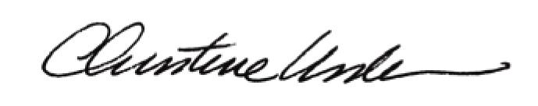

By:

Date of Meeting: June 20, 2016 Title: Historic Officer